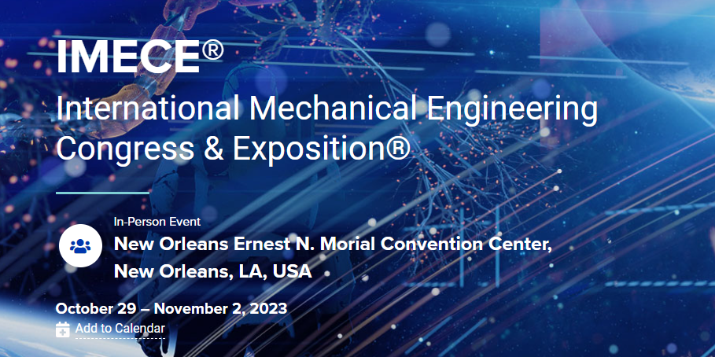

Special Panel Sessions
Wednesday, November 1, 2023
Panel: 2:00pm – 4:00pm | Additional discussion: 4:00pm – 6:00pm
Room 388, Convention Center

Frontiers of Manufacturing: In-Process Nondestructive Evaluation
Organizers: Yuris Dzenis, Gary Georgeson, Janis Terpenny
Moderator: Gary Georgeson, Boeing R&T (emeritus) & Georgeson Consulting
Co-Sponsored by ASME Nondestructive Evaluation & Prognostics Division (NDPD), Intelligent Manufacturing Technology Group (IMTG), and Technical and Engineering Communities Sector (TEC)
Description: This panel aims to explore the prospects of in-process nondestructive evaluation (NDE) during next generation manufacturing of structural components. Panelists comprising leading experts in manufacturing and NDE from academia and industry will discuss recent advances in the field and how continuous monitoring of emerging complex manufacturing processes can transform the industry and accelerate adoption of new rapid, additive, and high-rate processes for demanding structural applications. Challenges, opportunities, and needs will be covered from research and workforce development prospectives. Value proposition for the use of in-process NDE will be presented. Possible contribution of real-time NDE to future smart digital manufacturing and Industry 4.0/5.0 will be discussed. Join us to learn about relevant emerging technologies elucidated via engaging discussion.
Our Panelists:

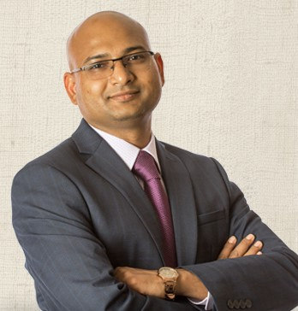  Sourav Banerjee, University of South Carolina | 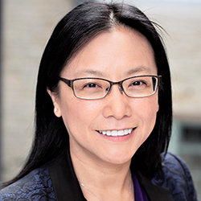  Jian Cao, Northwestern University | Christian Gobert, Sentient Science Corporation
Roman Maev, University of Windsor & Tessonics Group | Megan McGovern, General Motors R&D | 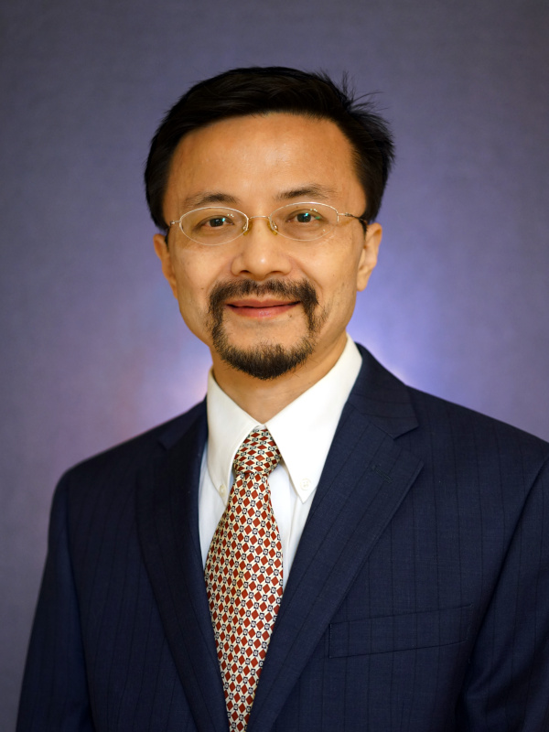  Yan Wang, Georgia Institute of Technology

