Finite Element Analysis

Many technical devices and processes are designed today using numerical simulation techniques. One such technique is termed Finite Element Analysis (FEA), also referred to as the Finite Element Method. Simulation tools, like FEA, enable design engineers to determine whether a product will function or a process will be successful before the device is even built or the process tested.

Before engineers developed effective simulation techniques, they had to build a product or erect a plant using a process to see if their designs would work in practice. For example, no way existed to reliably calculate the impact of projectiles, the effect of explosions, the strength of boilers, or the trajectories of space vehicles short of building and operating the devices. This could be prohibitively expensive, wasteful, and/or dangerous, especially if the product or process did not work as planned. With the maturation of simulation, many tests that once had to be performed using fully developed physical objects could be performed virtually -- before construction. This transition revolutionized all disciplines of engineering and science.

Among the simulation tools, the finite element method has been the most powerful and ubiquitous. It has been used to solve problems of stress/strain/deformation, problems in the thermal sciences (heat transfer and fluid mechanics), in electromagnetic studies/circuit analysis, in vibration, in manufacturing, and other fields. FEA originated from the need to solve complex elasticity structural analysis problems in civil and aeronautical engineering. It has since been adopted in other technical areas and has become a major tool in both the applied and basic sciences.

The finite element method essentially breaks an object to be studied into a multitude of finite-sized elements. Computer software then applies various conservation laws to each element – written in finite rather than differential form. The software solves these equations for each element and then combines the results – a process that provides a solution across the entire domain. This process is akin to a jigsaw puzzle where a small part of the whole picture is created on each puzzle piece. When all the puzzle pieces are correctly assembled, the whole picture appears.

Example images showing FEA results are provided below. In the first image, stress within an axle assembly is shown. The focus of the image is the right-hand side of the assembly, dark blue corresponds to low stress areas. Green, yellow, and red signify high stress.

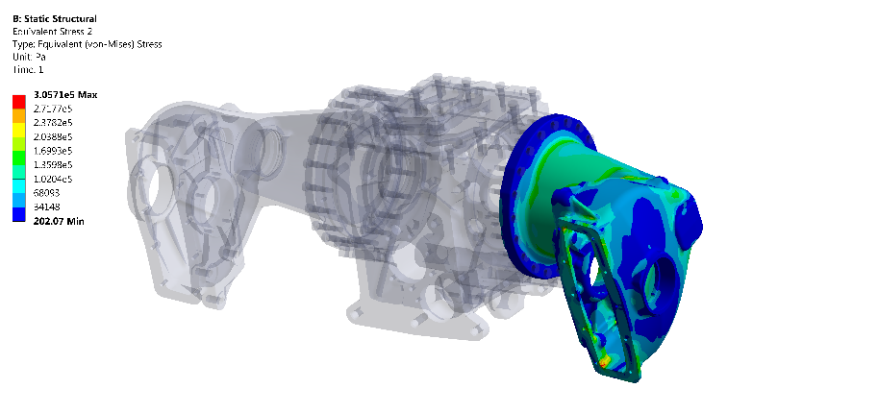
Stress distribution in an axle, courtesy of ANSYS Corp

The following image shows deformation in a human spine. The blue colors show little deformation while the orange and red colors indicate larger deformation. Such simulations are used to characterize motion and to design medical devices.
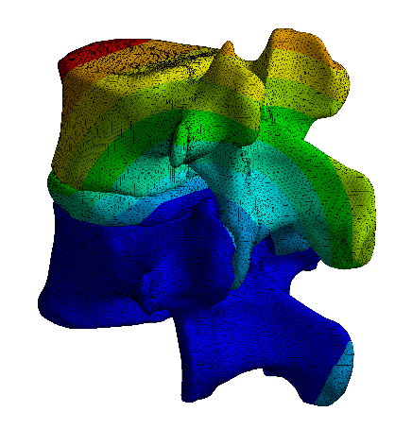
Deformation within a human spine, courtesy of ANSYS Corp.

The last image shows movement and vibration patterns within a gear assembly. The blue regions are non-moving and non-vibrating. The orange and red zones indicate extensive movement and vibration.

. 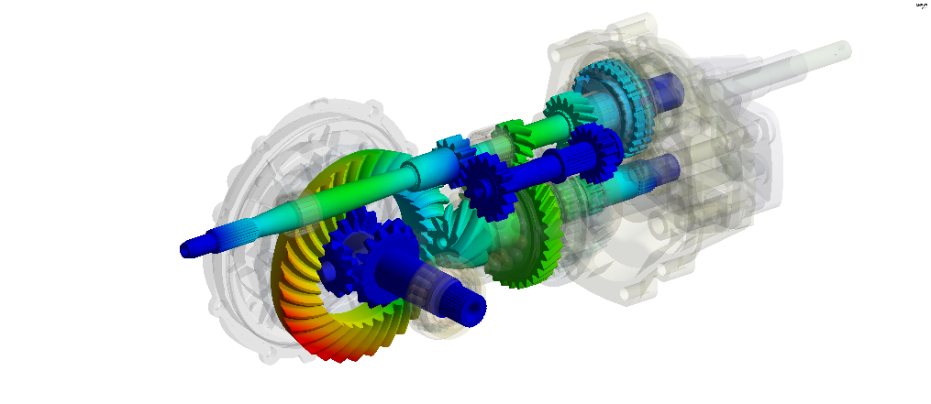
Mode shape within a gearbox, courtesy of ANSYS Corp.

FEA is used regularly in many engineering industries, especially the aerospace and automotive industries, to accurately determine stress distribution in complex components.

Other areas where FEA is employed include:

The nuclear industry

Geosciences and climate studies

The renewable energy sector (wind power, solar power, hydro power)

Medical device and process design and evaluation, particularly for implanted medical devices

Food-processing

Manufacturing

Electronics and controls
This is but an abbreviated list – designed to convey FEA’s breadth of application. The method is employed in virtually every Science, Technology, Engineering and Math (STEM) discipline, and one major benefit of employing this technique is that you can converge on a reliable design before building physical prototypes.
HISTORICAL BACKGROUND

The finite element method is a numerical algorithm (a set of rules to be followed in calculations); it is not a physical object. FEA evolved over many years, and there is no distinct marker to assign its development to any one individual or entity. Indeed, it can be argued that the third century BC Greek engineer and mathematician Archimedes (c. 287 – c. 212 BCE) used finite “elements” in determining the volume of solids. He calculated areas, lengths, and volumes of complex geometrical objects by dividing them into progressively smaller units and adding these, until reaching an arbitrary degree of accuracy.

Efforts to quantify weather prediction in the 1920s led to major advances in computational techniques. While these early weather calculations did not use the exact mathematical approach of FEA, they broke complex calculations into smaller pieces and combined the results to cover broad problems. This was very similar to FEA and helped pave future developments. These efforts began approximately 100 years ago with pioneers such as Vilhelm Bjerknes and Lewis Fry Richardson (1922) [1] who gave us the fantastical “forecast factory” concept for carrying out the many repetitive calculations needed to make numerical predictions [2].

However, the finite element method first gained widespread traction beginning with the work of M. J. (Jon) Turner at Boeing over the period 1950–1962. Turner generalized and perfected the Direct Stiffness Method, which used FEA, and convinced Boeing to commit resources to it, including computer hardware and software. The adoption of the finite element method by an important industrial company was a major milestone in it gaining acceptance elsewhere.
Development of the finite element method began in earnest in the middle to late 1950s for airframe and structural analysis and gathered momentum in the 1960s at the University of Stuttgart through the work of John Argyris and at Berkeley through the work of Ray W. Clough for use in civil engineering. By late 1950s, the key concepts of stiffness matrix and element assembly existed essentially in the form used today, and peer-reviewed scientific publications began to appear [3]

Recognizing that FEA involved numerous calculations and that only the calculation speeds provided by computers would permit expanded use of the method, the National Aeronautics and Space Administration issued a request for proposals for the development of the finite element software NASTRAN in 1965. The race to develop quality commercial FEA software had started. A good survey of FEA history is provided by Mohite [4].

As key industrial firms and government agencies expanded use of FEA in technological development, interest developed in academic communities. A number of people were important for this information transfer. Perhaps most noteworthy were Zienkiewicz, Martin, Clough (already mentioned), and Argyris [5] (already mentioned). These four held academic positions at various universities and helped expand training opportunities for their colleagues.

Another set of milestones was the publication of textbooks on the subject. Among the first was by Strang and Fix (1973) [6], but the textbook space became populated quickly. While many manuscripts on the FEA technique have been published -- and continue to be published, -- the underlying principles were well articulated by the 1960s -1970s.

FINITE ELEMENT ANALAYSIS TODAY

The world would be very different without FEA. Simply stated, today FEA is used to design and evaluate many devices in a virtual environment, before any physical copies are made for testing. Classic examples include aircraft and cars. FEA techniques measure their aerodynamic performance, structural integrity, and ability to withstand pressures and forces, including vibration and fatigue, before these products are ever built. Other problems solved before production include heat transfer, fluid mechanics, and electro-magnetic issues. Similarly, engineers use FEA to predict how electronic devices (smart phones, computers, televisions, etc.) will perform before they are ever constructed. The finite element method is now ubiquitous in engineering and the sciences, used by all of today’s top engineering and science companies and a cornerstone of undergraduate and graduate education in engineering worldwide.

FEA is the most commonly used continuum modeling approach in the mechanical sciences (stress/strain/deformation); with the advent of easy-to-use commercial codes, FEA is at the fingertips of many practicing engineers. As a result of this tool, the cost and time to design products has been significantly reduced and safety improved. In some areas, FEA has made possible simulation where experimentation is not feasible, notably experimental medical procedures and devices. Ethics rules prohibit testing of high-risk devices or processes on living humans. Simulation through FEA is the only option.

There are other numerical algorithms (finite volume, boundary element, Monte Carlo, etc.) that can perform many of the same functions as FEA. These other methods are found within certain subdisciplines. For instance, the finite volume method is used often in Computational Fluid Dynamics analyses. Monte Carlo calculations are often used for radiation transport (heat transfer through light). However, there is no other computational method that has found such widespread and long-lasting application as Finite Element Analysis.

References
[1] Richardson, L. F., 1922. Weather Prediction by Numerical Process, Cambridge University Press, Cambridge, MA, USA.

[2] Lynch, P., 2006, The Emergence of Numerical Weather Prediction, Cambridge University Press, Cambridge MA, USA.

[3] Turner, M.J., R.W. Clough, H.C. Martin, and L.J. Topp, 1956. “Stiffness and deflection analysis of complex structures,” Journal of the Aeronautical Sciences, vol. 23, pp. 805-823.

[4] Mohite, P.M., 2019. “The Origins of the Finite Element Method,” available at: http://home.iitk.ac.in/~mohite/History_of_FEA.pdf

[5] Lazarus, T., and J. Argyris, 2013, “A Brief History of FEM,” pp. 17-25 in Finite Element Analysis for Composite Structures, Springer, Cham, Switzerland.

[6] Strang, G., and G. Fix, 1973. An Analysis of the Finite Element Method, Prentice Hall, Englewood Cliffs, NJ, USA.

About the Author:
Dr. John P. Abraham is a professor of Mechanical Engineering at the University of St. Thomas in Minnesota. He has worked on fundamental and applied engineering problems using numerical models such as the FEA. He works both with personal and commercial code in his teaching and research. He has published approximately 300 works (including journal papers, conference presentations, book chapters, books, and patents). Most of his work is in the biological heat/fluid flow area as well as the renewable energy and laminar/turbulent fluid flow.

Historical Mechanical Engineering Landmark
Finite Element Analysis
1950s

Finite Element Analysis (FEA) is a computational method used to simulate, or predict, how a part, assembly, or process will behave under given conditions. Before FEA simulation, engineers fabricated devices to determine if designs worked. FEA enabled engineers to design and evaluate these in a virtual environment, before physical copies were made. This made design significantly faster and more economical. FEA techniques emerged incrementally over the centuries, but first gained widespread recognition with the work of M. J. (Jon) Turner at Boeing in the 1950s. The growing availability of computers to solve the complex equations inherent to FEA led to widespread use of simulation techniques in design from the 1960s onward.

