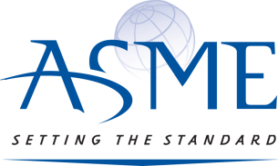

March 7, 2022

ATTENTION OTC 2022 EXHIBITORS:

Enter your latest technologies for judging of the:

ASME 37th Annual Woelfel Best Mechanical Engineering Achievement Award

Dear OTC 2022 Exhibitor:

As a co-sponsor of OTC 2022, the Petroleum Division of invites you to enter the 37th Annual Woelfel Best Mechanical Engineering Achievement Award, open only to OTC 2022 exhibitors.

This prestigious award recognizes a product, device, or system displayed at the OTC Conference, which best reflects innovation and/or practical use of mechanical engineering in solving problems, improving design or maximizing performance.

The ASME Petroleum Division will present this award at a private reception at the start of OTC. This will give a broad opportunity for the winner and finalists to be visited and their displays viewed by industry media during OTC week. An announcement of winners and all finalists will be made to OTC media.

The ASME judging committee will review the entries and narrow the competition to finalists prior to OTC 2022. The finalists will be identified by signs and literature at the OTC exhibition. The judging committee will visit the finalists’ displays on opening day and select a winner. Industry media will be notified and invited to visit the winning displays.

The deadline for the Woelfel BMEA is April 15, 2022. (Extended due to technology issues)
For more information, a list of past winners and an application, visit our website: https://www.asme.org/about-asme/honors-awards/unit-awards/otc-woelfel-achievement-award-oil-drop

Please follow directions at the bottom of the submission form on how to submit your application for the BMEA award.

Best regards,

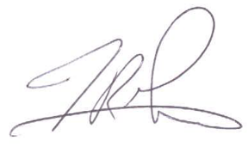

Timothy R. Graves
Managing Director of Technical Conferences & Member Communities
ASME
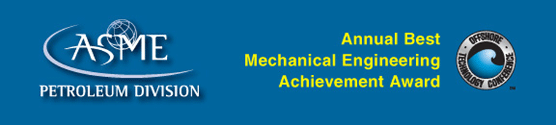

Past winners include:

2019
AFGlobal Corporation – Active Control Device (ACD) (Innovation) & DuraStim® Pump (Achievement)

2018
Baker Hughes, a GE Company - Kymera™ Mach 4 Hybrid Drill Bit

2017
Frank’s International Combination Drillpipe and Casing Handling System – Achievement
TechnipFMC 15K 400°F HPHT Subsea Production System - Innovation

2016
Aker Solutions – CL4 Subsea Electric Actuator, EL-Drive®

2015
Versabar – Versacutter
2014
Baker Hughes for Harpoon Cut and Pull – Achievement
FMC Technologies for Offshore Loading Arm Footless (OLAF) – Innovation

2013
Managed Pressure Operations, part of Aker Solutions for Riser Safety System (RSS)
2012
Baker Hughes for the MaxCOR Large-Diameter Rotary Sidewall Coring Service

2011
Aker Solutions for VCS, Vertical Connection System - Achievement
Deep Down, Inc. for the 3,400 Ton Umbilical Carousel – Innovation
2010
Nautilus Rigging for Nautilus Hooks
2009
Offshore Solutions, BV for Offshore Access System (OAS)
2008
Yantai Raffles for “TAISUN”- 20’000MT gantry crane with multiple hoists - Achievement
Versabar for Versabar “Bottom Feeder”- Innovation
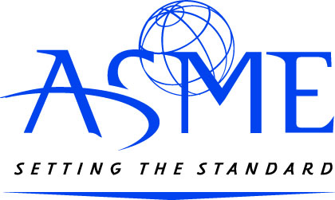

FEATURED OR DISPLAYED BY EXHIBITORS ONLY AT THE
2022 OFFSHORE TECHNOLOGY CONFERENCE – HOUSTON, TEXAS

OFFICIAL ENTRY FORM

(Please Type)

1. Name of product, device or system (how it is identified - including trade name)

2. Company (or individual) responsible for design. Include complete name, address, telephone number and email.

3. When was the design completed? Month/year

4. When was it offered to the market? Month/year

5. Was this design previously described in any publication? No_____ Yes Which?

6. Is this idea patented?
Patent No. Patent applied for and Serial No.

Use additional paper to complete the following and attach to entry form.

7. What was the design/development problem? What needed improvement or correction?

8. Describe the design/development solution to the problem.
(Include documentation such as blueprints, drawings, sketches or photographs that show what was done. Judges may reject designs they do not understand because of inadequate descriptive accompaniment.)

9. Describe the specific innovation in mechanical engineering.

10. What benefits to the manufacturer were realized through this design?

- What benefits to the user were realized through this design?

- Please take under consideration the following judging criteria in no particular order:

  - Novelty
  - Impact on Industry
  - HSE
  - State of Development
  - Presentation

13. Submitted by: Main Contact

Company

Mailing Address

City State Zip

Telephone: (______) ______________________ Fax: (_____) _______________________

E-Mail:_____________________________________

Submission
- Each entry is asked to enclose illustrations, photos and videos of your product to enhance the description of your entry for the judges. Finalists will be required to submit 2 minute videos (MP3) of your product to be shown during our awards ceremony.
- 1 electronic copy of this form is required of all entries using either email or other approved method.
- If you do not receive confirmation within 24 hours that your entry has been received, please contact Danielle Rojas at rojasd@asme.org
    - Email submission form along with images/videos/illustrations of the technology in a zipped file to: Danielle Rojas, rojasd@asme.org
    - If your file is too large for email, please use the following dropbox to turn in your submission documents in a zipped file.
      - Submit application here: https://asme.sharefile.com/remoteupload/a6b9c483-281d-47e7-9273-0f4a0aaee8f9

Electronic copy of all entries due to Danielle Rojas at RojasD@asme.org
by April 15, 2022.
Deadline was extended due to technical issues with the application form.

Please contact Danielle Rojas, 281-810-5461 or rojasd@asme.org with
any questions regarding this award and any submission issues.

Updates and additional information can be found on the Petroleum Division group webpage: https://www.asme.org/about-asme/honors-awards/unit-awards/otc-woelfel-achievement-award-oil-drop

